# Analyzing the Behavior of Exchanges in United States

*Big Data Project Report by*

***Saloni Bindra*** ***Monica Reddy Tirupari***

**Overview**

The main purpose is to find different trends in the working of exchanges in United States. A lot of work has been done in predicting the behavior of stocks from the history of stock process. However, here we have considered the data of all the stocks traded in an exchange, this data is nothing but the messages passed for various stages of ordering shares.

**Architecture**:

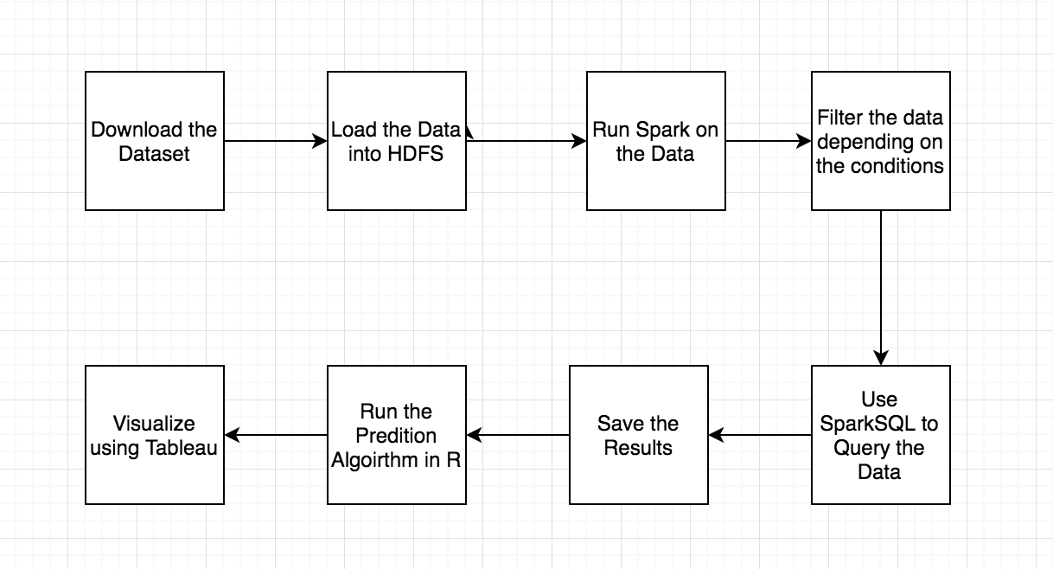

**Technologies used:**

* **Spark (PySpark)** - Loading and Filtering the Data
* **SparkSQL** – Query Processing
* **R** – Prediction Algorithm
* **Tableau** and **Python Plotly** - Visualizations

**Dataset**:

* Provided by US Securities and Exchange Commission
* It provides metrics for each individual security for each exchange
* Attributes: Ticker, Date, Security, McapRank, TurnRank, VolatilityRank, PriceRank, Cancels, Trades, LitTrades, OddLots, Hidden, TradesForHidden, OrderVol, TradeVol, LitVol, OddLotVol, HiddenVol, TradeVolForHidden

The following is the URL for the dataset used:

<https://www.sec.gov/opa/data/market-structure/market-structure-data-security-and-exchange.html>

**Details about the dataset:**

* Order-based exchanges: Arca, Bats-Y, Bats-Z, Boston, CHX, Edga-A, Edge-X, Nasdaq, NSX, PHLX
* Level-book exchanges: Amex, NYSE
* Exchanges denote trades against hidden orders: Arca, Bats-Y, Bats-Z, Boston, Edga-A, Edge-X, Nasdaq, PHLX
* Exchanges do not denote trades against hidden orders: Amex, CHX, NSX, NYSE
* Exchanges do not report trades against individual orders: Amex, NYSE
* Trades, Trade Volume, Hidden, Hidden Volume, Odd Lots and Odd Lot Volume are counted/summed from the direct feeds for: Arca, Bats-Y, Bats-Z, Boston, Edga-A, Edge-X, Nasdaq, PHLX
* Trades, Trade Volume, Odd Lots and Odd Lot Volume are counted/summed from the direct feeds for: CHX, NSX
* Trades, Trade Volume, Odd Lots and Odd Lot Volume are counted/summed from the SIP feeds for: Amex, NYSE
* Hidden and Hidden Volume are computed as the difference between Trades/Trade Volume reported on the SIP feed and Trades/Trade Volume reported on the direct feeds for: Amex, NYSE
* Hidden and Hidden Volume are not reported for: CHX, NSX

**Terminologies**:

For monthly (Date, Ticker, Exchange) data:

Trades: Count of all trade messages.

TradeVol('000): Sum of trade volume for all trade messages.

Cancels: Count of all cancel messages, either full or partial, for all exchanges.

Hidden: Count of trades against hidden orders from exchanges that report trades against hidden orders. Difference between SIP Trades and Direct Trades for NYSE and Amex.

LitTrades: Count of all trade messages for trades that are not against hidden orders. Computed as the difference between Trades and Hidden.

LitVol('000): Sum of trade volume for trades that are not against hidden orders. Computed as the difference between Trade Volume and Hidden Volume.

OrderVol('000): Sum of order volume for all add order messages.

TradesForHidden: Count of trades from exchanges that report trades against hidden orders.

HiddenVol('000): Sum of trade volume for trades against hidden orders from exchanges that report trades against hidden orders.

TradeVolForHidden('000): Sum of trade volume from exchanges that report trades against hidden orders.

OddLots: Count of odd lot trade messages for all exchanges.

OddLotVol('000): Sum of odd lot trade volume for all exchanges.

For quarterly (Date, Ticker) data:

TradesForOddLots = Trades: Count of trades from order-based exchanges.

TradeVolForOddLots('000) = TradeVol('000): Sum of trade volume from order-based exchanges.

**The metrics:**

Cancel-to-Trade = Cancels/LitTrades for Arca, Bats-Y, Bats-Z, Boston, CHX, Edga-A, Edge-X, Nasdaq, NSX, PHLX

Trade-to-Order-Volume = Sum of Total Amount of Trade/Sum of Total amount of Order for All Exchanges

Hidden Rate = 100*Hidden/TradesForHidden for Arca, Bats-Y, Bats-Z, Boston, Edga-A, Edge-X, Nasdaq, PHLX (& Amex and NYSE from 2014)

Hidden Volume = 100*HiddenVol/TradeVolForHidden for Arca, Bats-Y, Bats-Z, Boston, Edga-A, Edge-X, Nasdaq, PHLX (& Amex and NYSE from 2014)

Oddlot Rate=100*OddLots/TradesForOddLots for Arca, Bats-Y, Bats-Z, Boston, CHX, Edga-A, Edge-X, Nasdaq, NSX, PHLX

Oddlot Volume=100*OddLotVol/TradeVolForOddLots for Arca, Bats-Y, Bats-Z, Boston, CHX, Edga-A, Edge-X, Nasdaq, NSX, PHLX

**List of Exchanges:**

* ACRA
* PHIX
* NSX
* NASDAQ
* EDGE-X
* EDGE –A
* CHX
* BOSTON
* BATS – Z
* BATS –Y
* AMEX
* NYSE

Since the data has around 5717 stocks for each exchange, for visualization purpose we have considered the following stocks.

Please note: the code has been run on all the data and the results for each of these 5717 stocks have been taken into consideration. Only top 15 stocks have been chosen for visualization purpose

**Sample Stocks**

* SPY – SnP500
* AAPL – Apple
* FB - Facebook
* GDX – VanEck Investment
* MSFT - Microsoft
* UVXY – PowerShare ETF
* GOOGL – Alphabet Inc
* IWM – Index Fund
* XLE – Energy Sector
* GILD - Gilead Sciences
* QQQ- Powershare Series
* XOP – SNP Oil & Gas
* NFLX – Netflix

**Visualizations:**

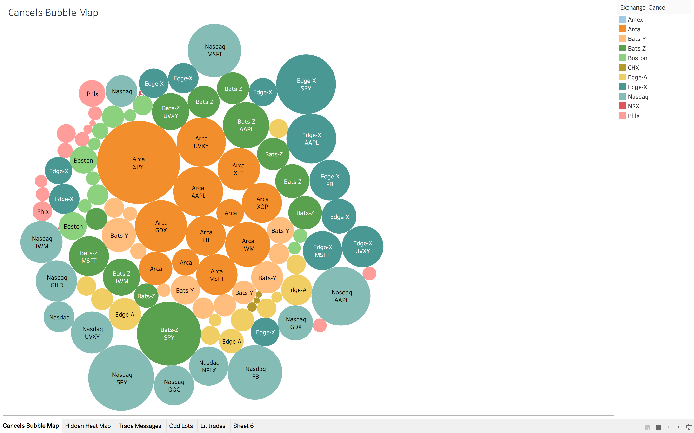

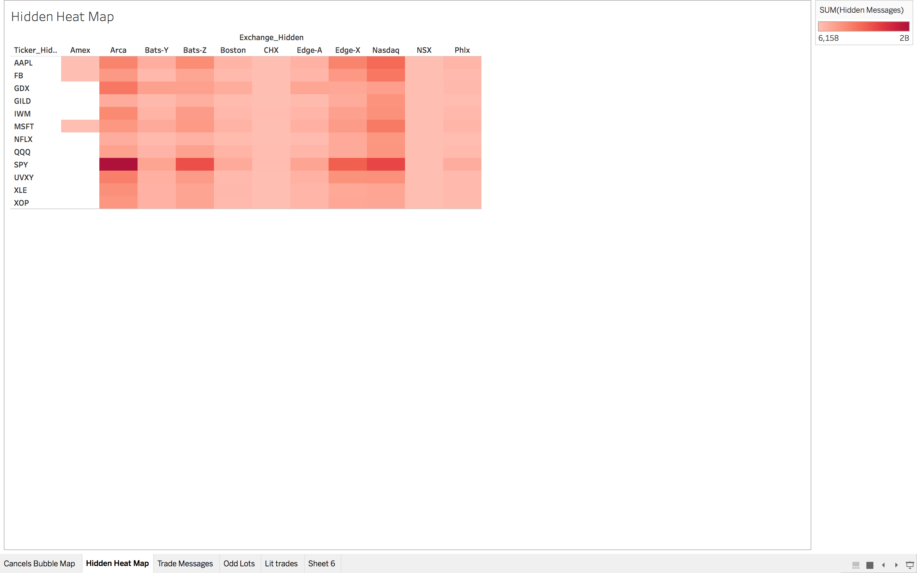

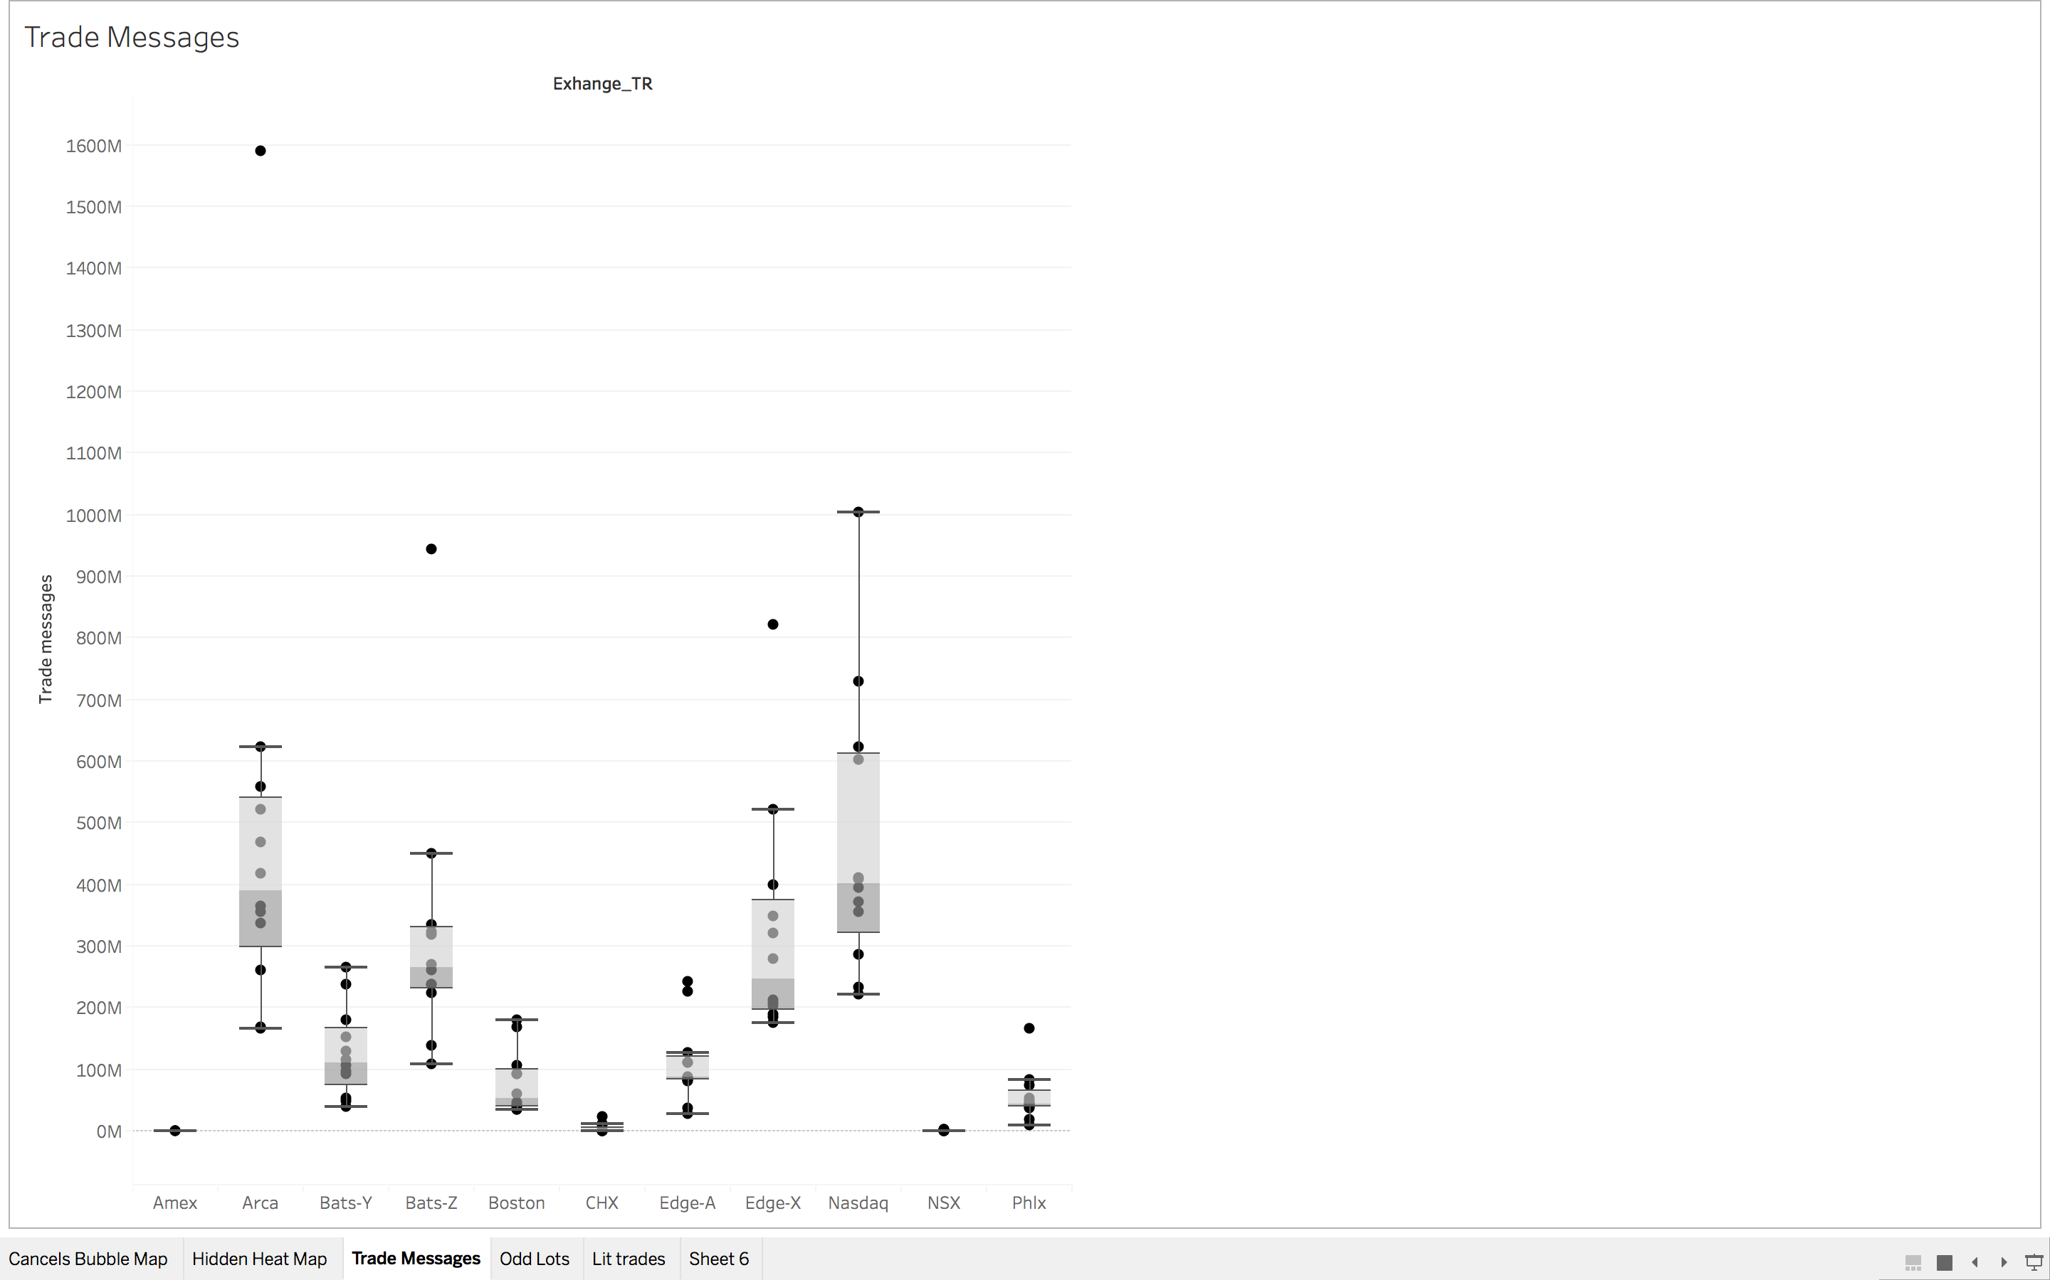

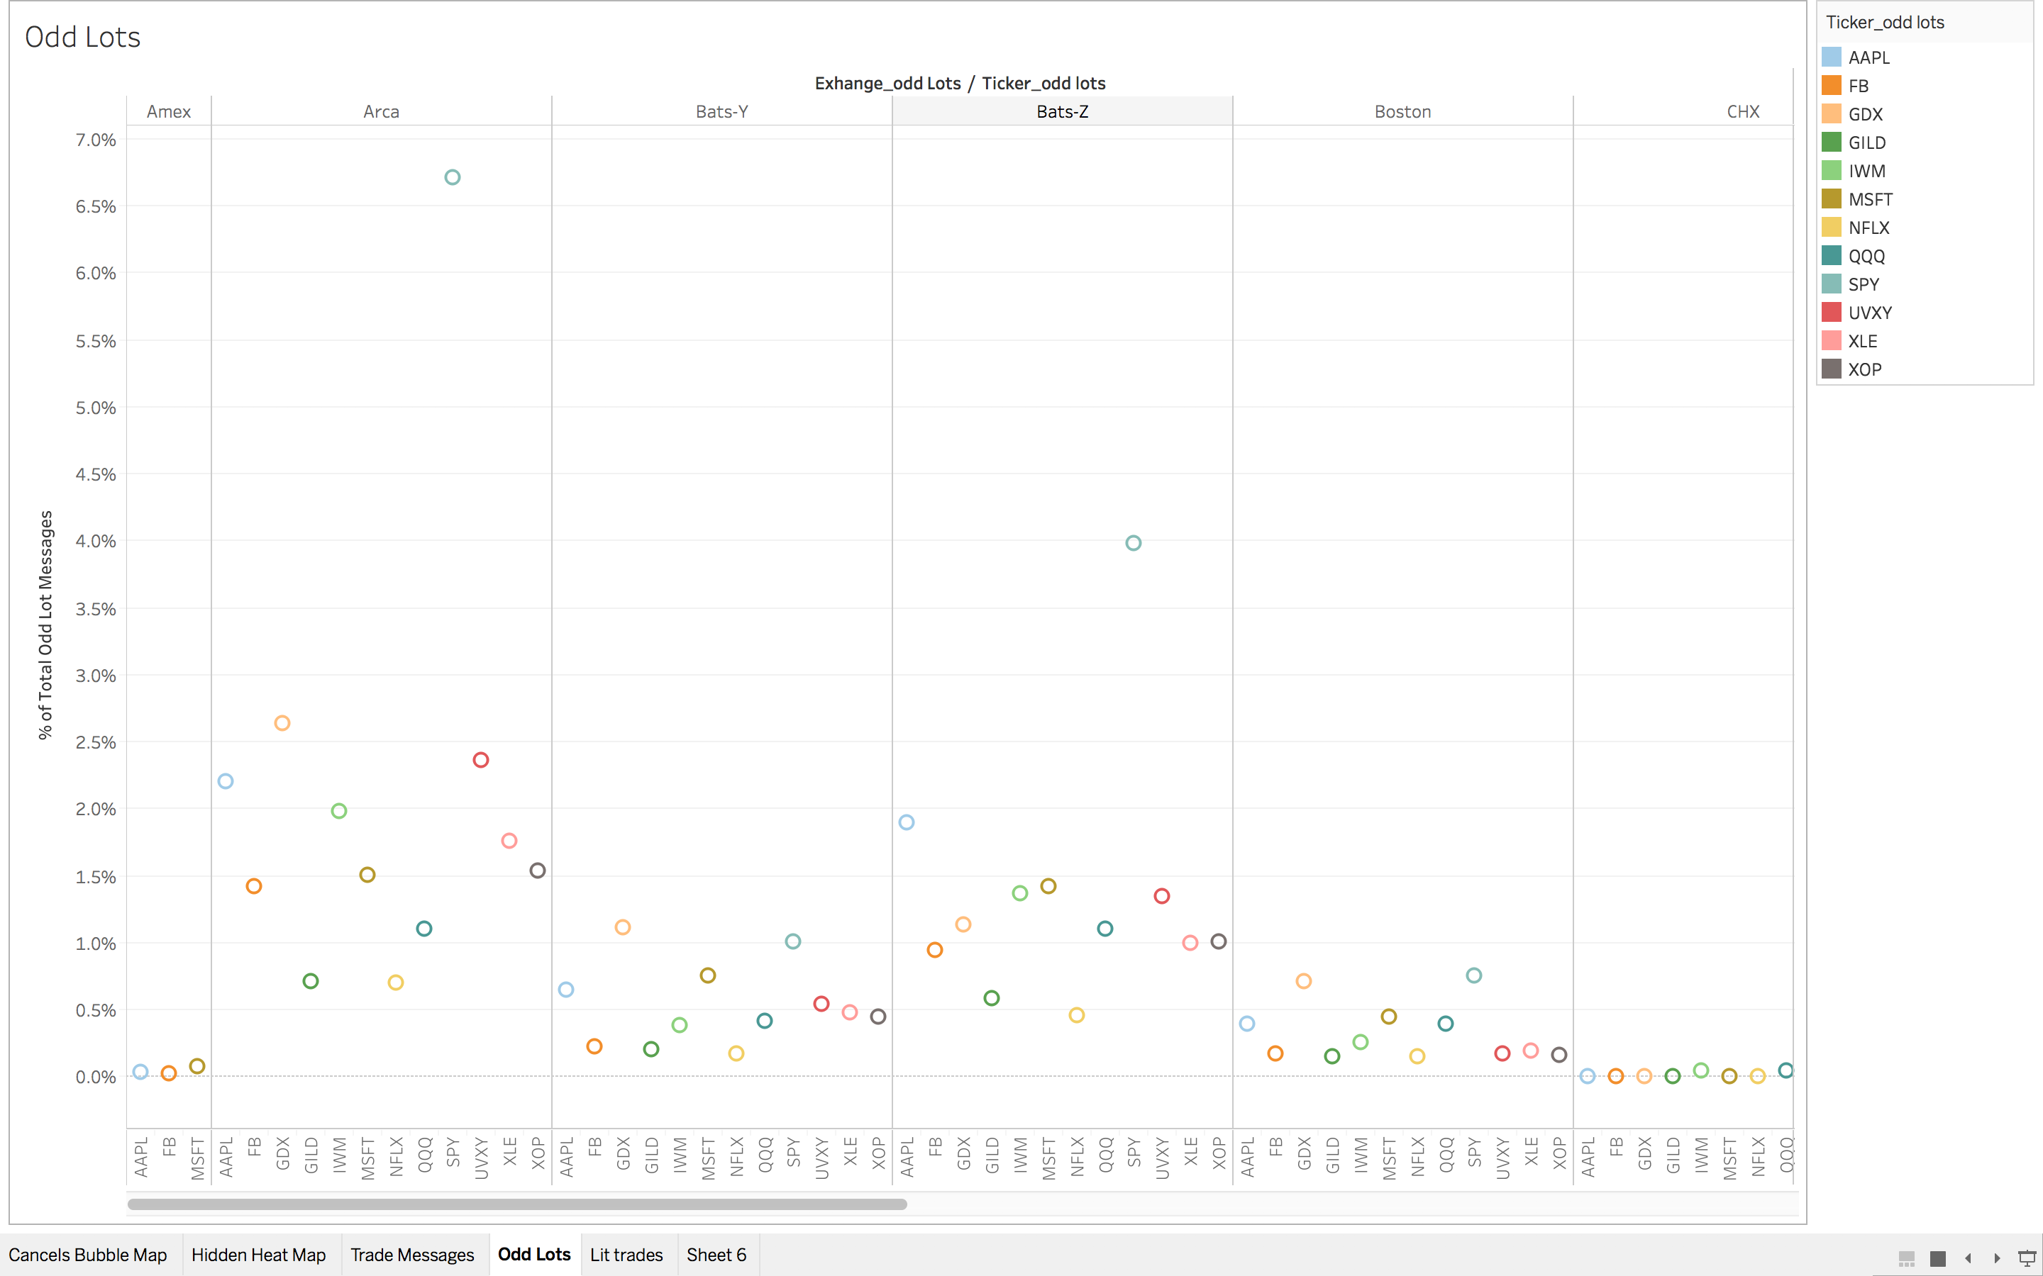

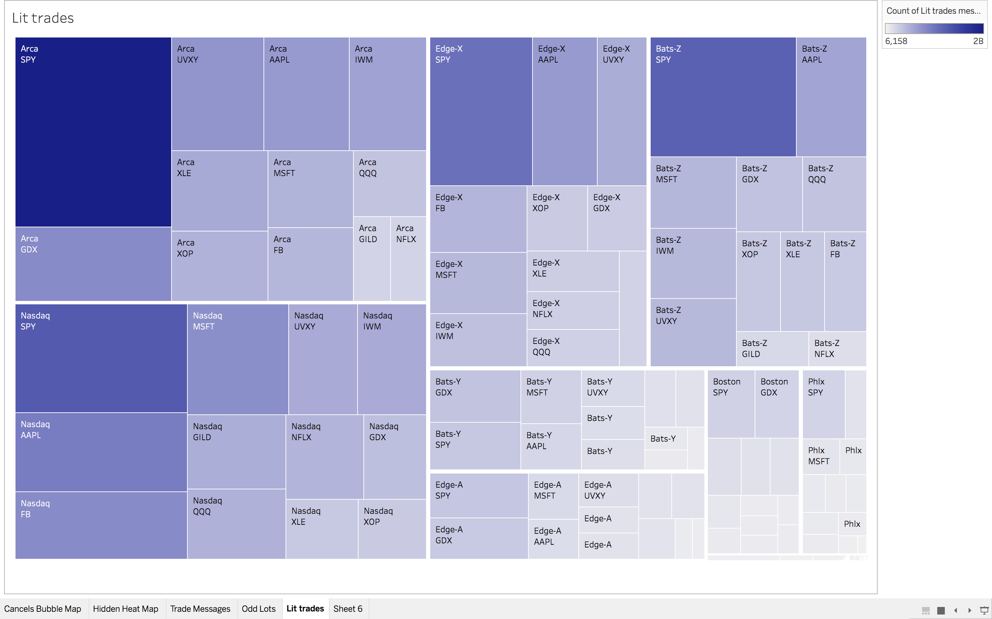

Code and output files for the above plotted figures can also be found at: <https://github.com/salonibindra2050/Big-Data-Analytics>

Following Snapshots are some of the code snippets:

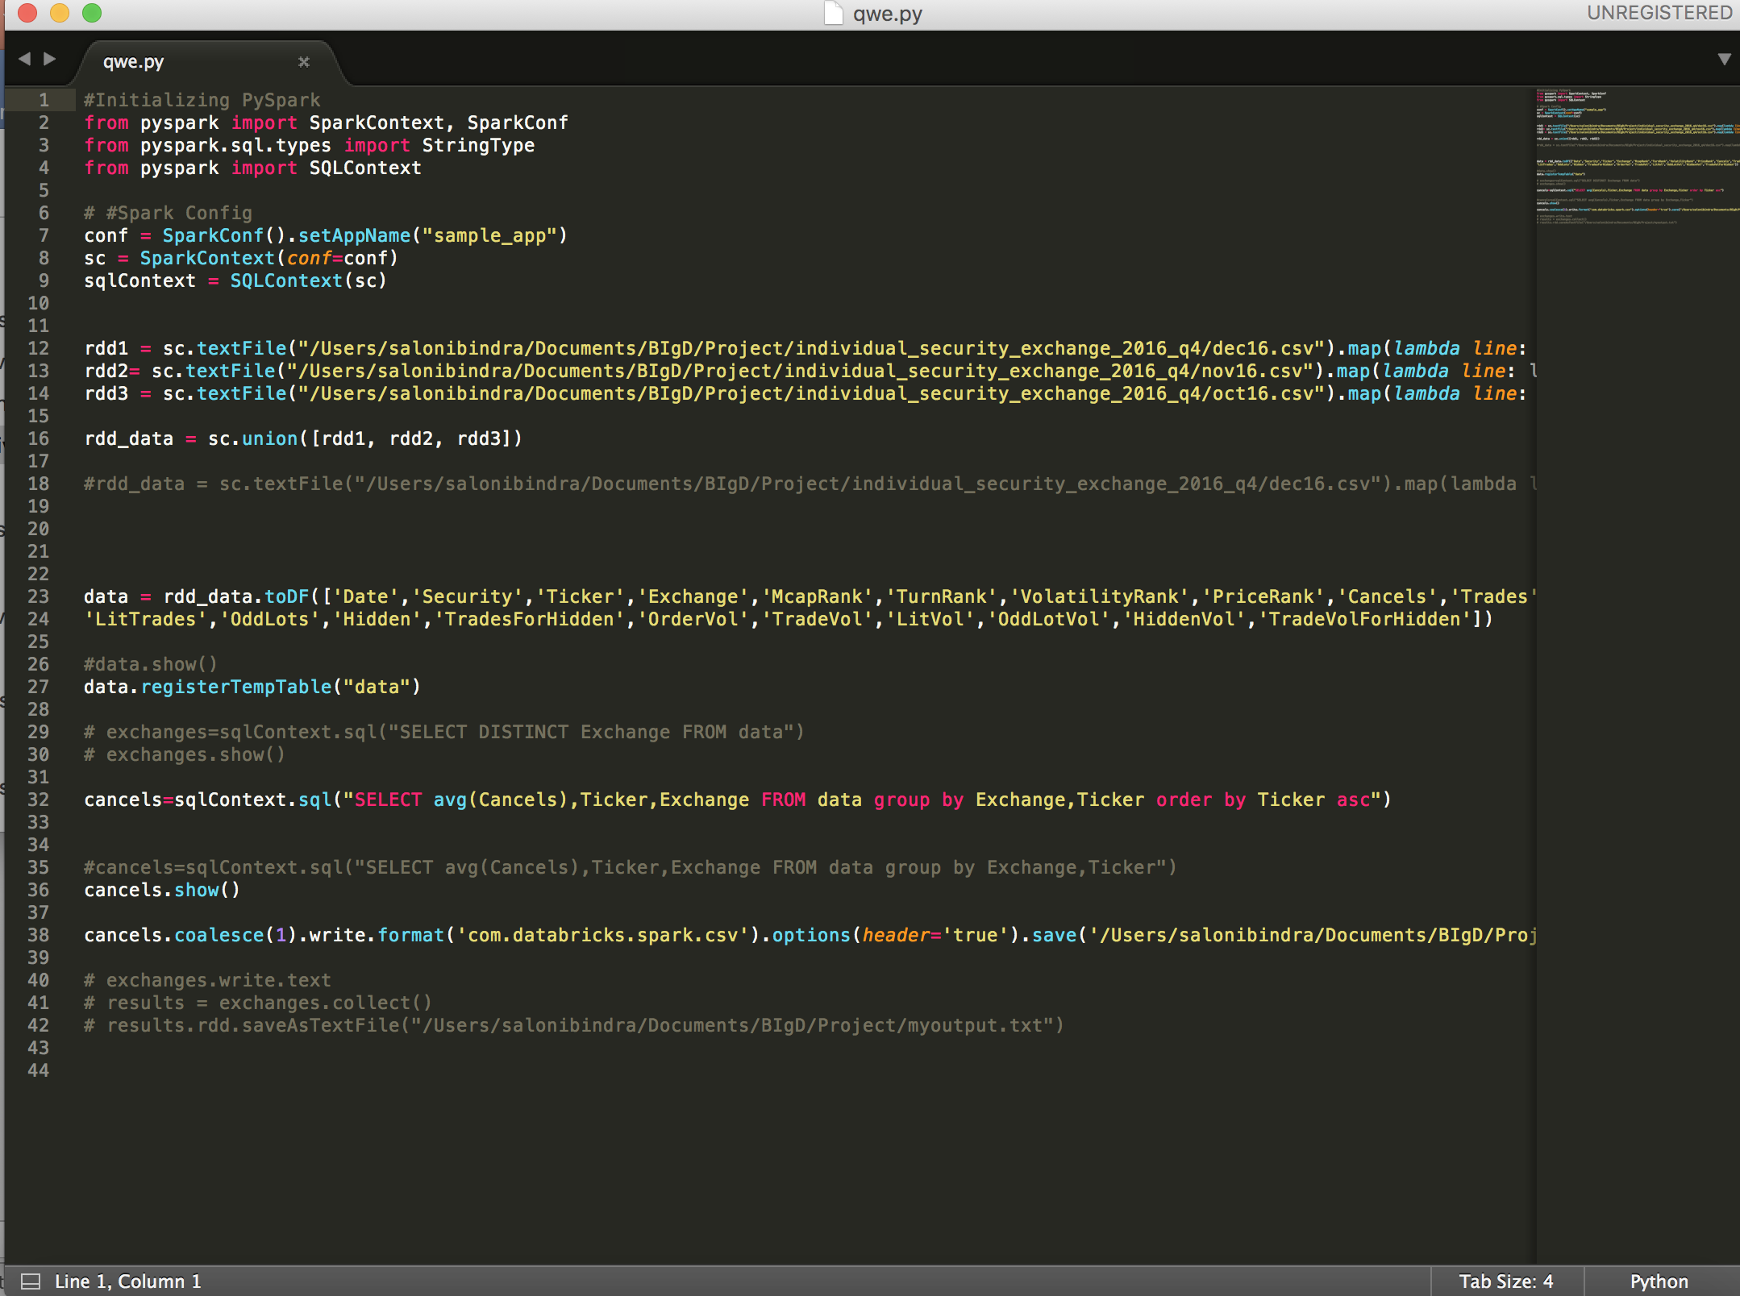

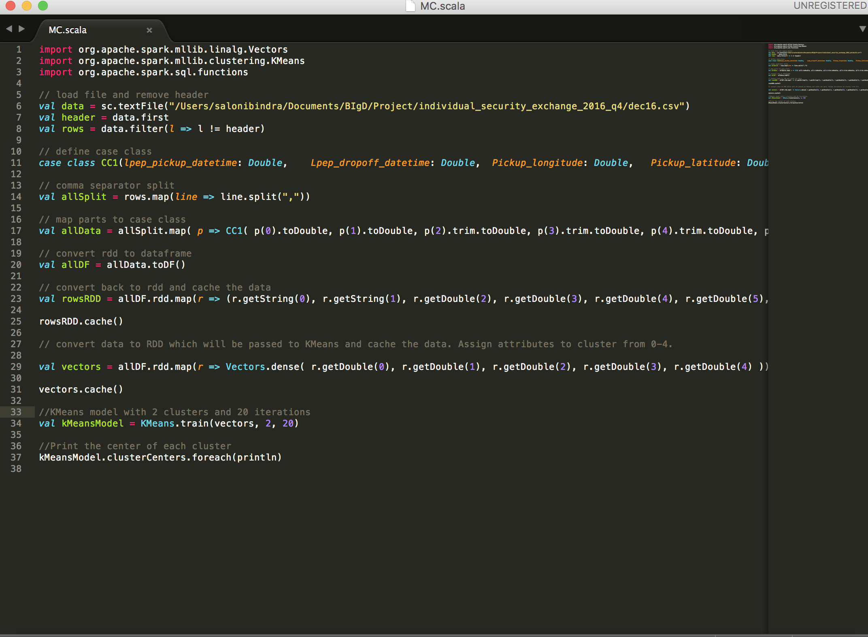

**Trade to Order Volume for Each Exchange:**

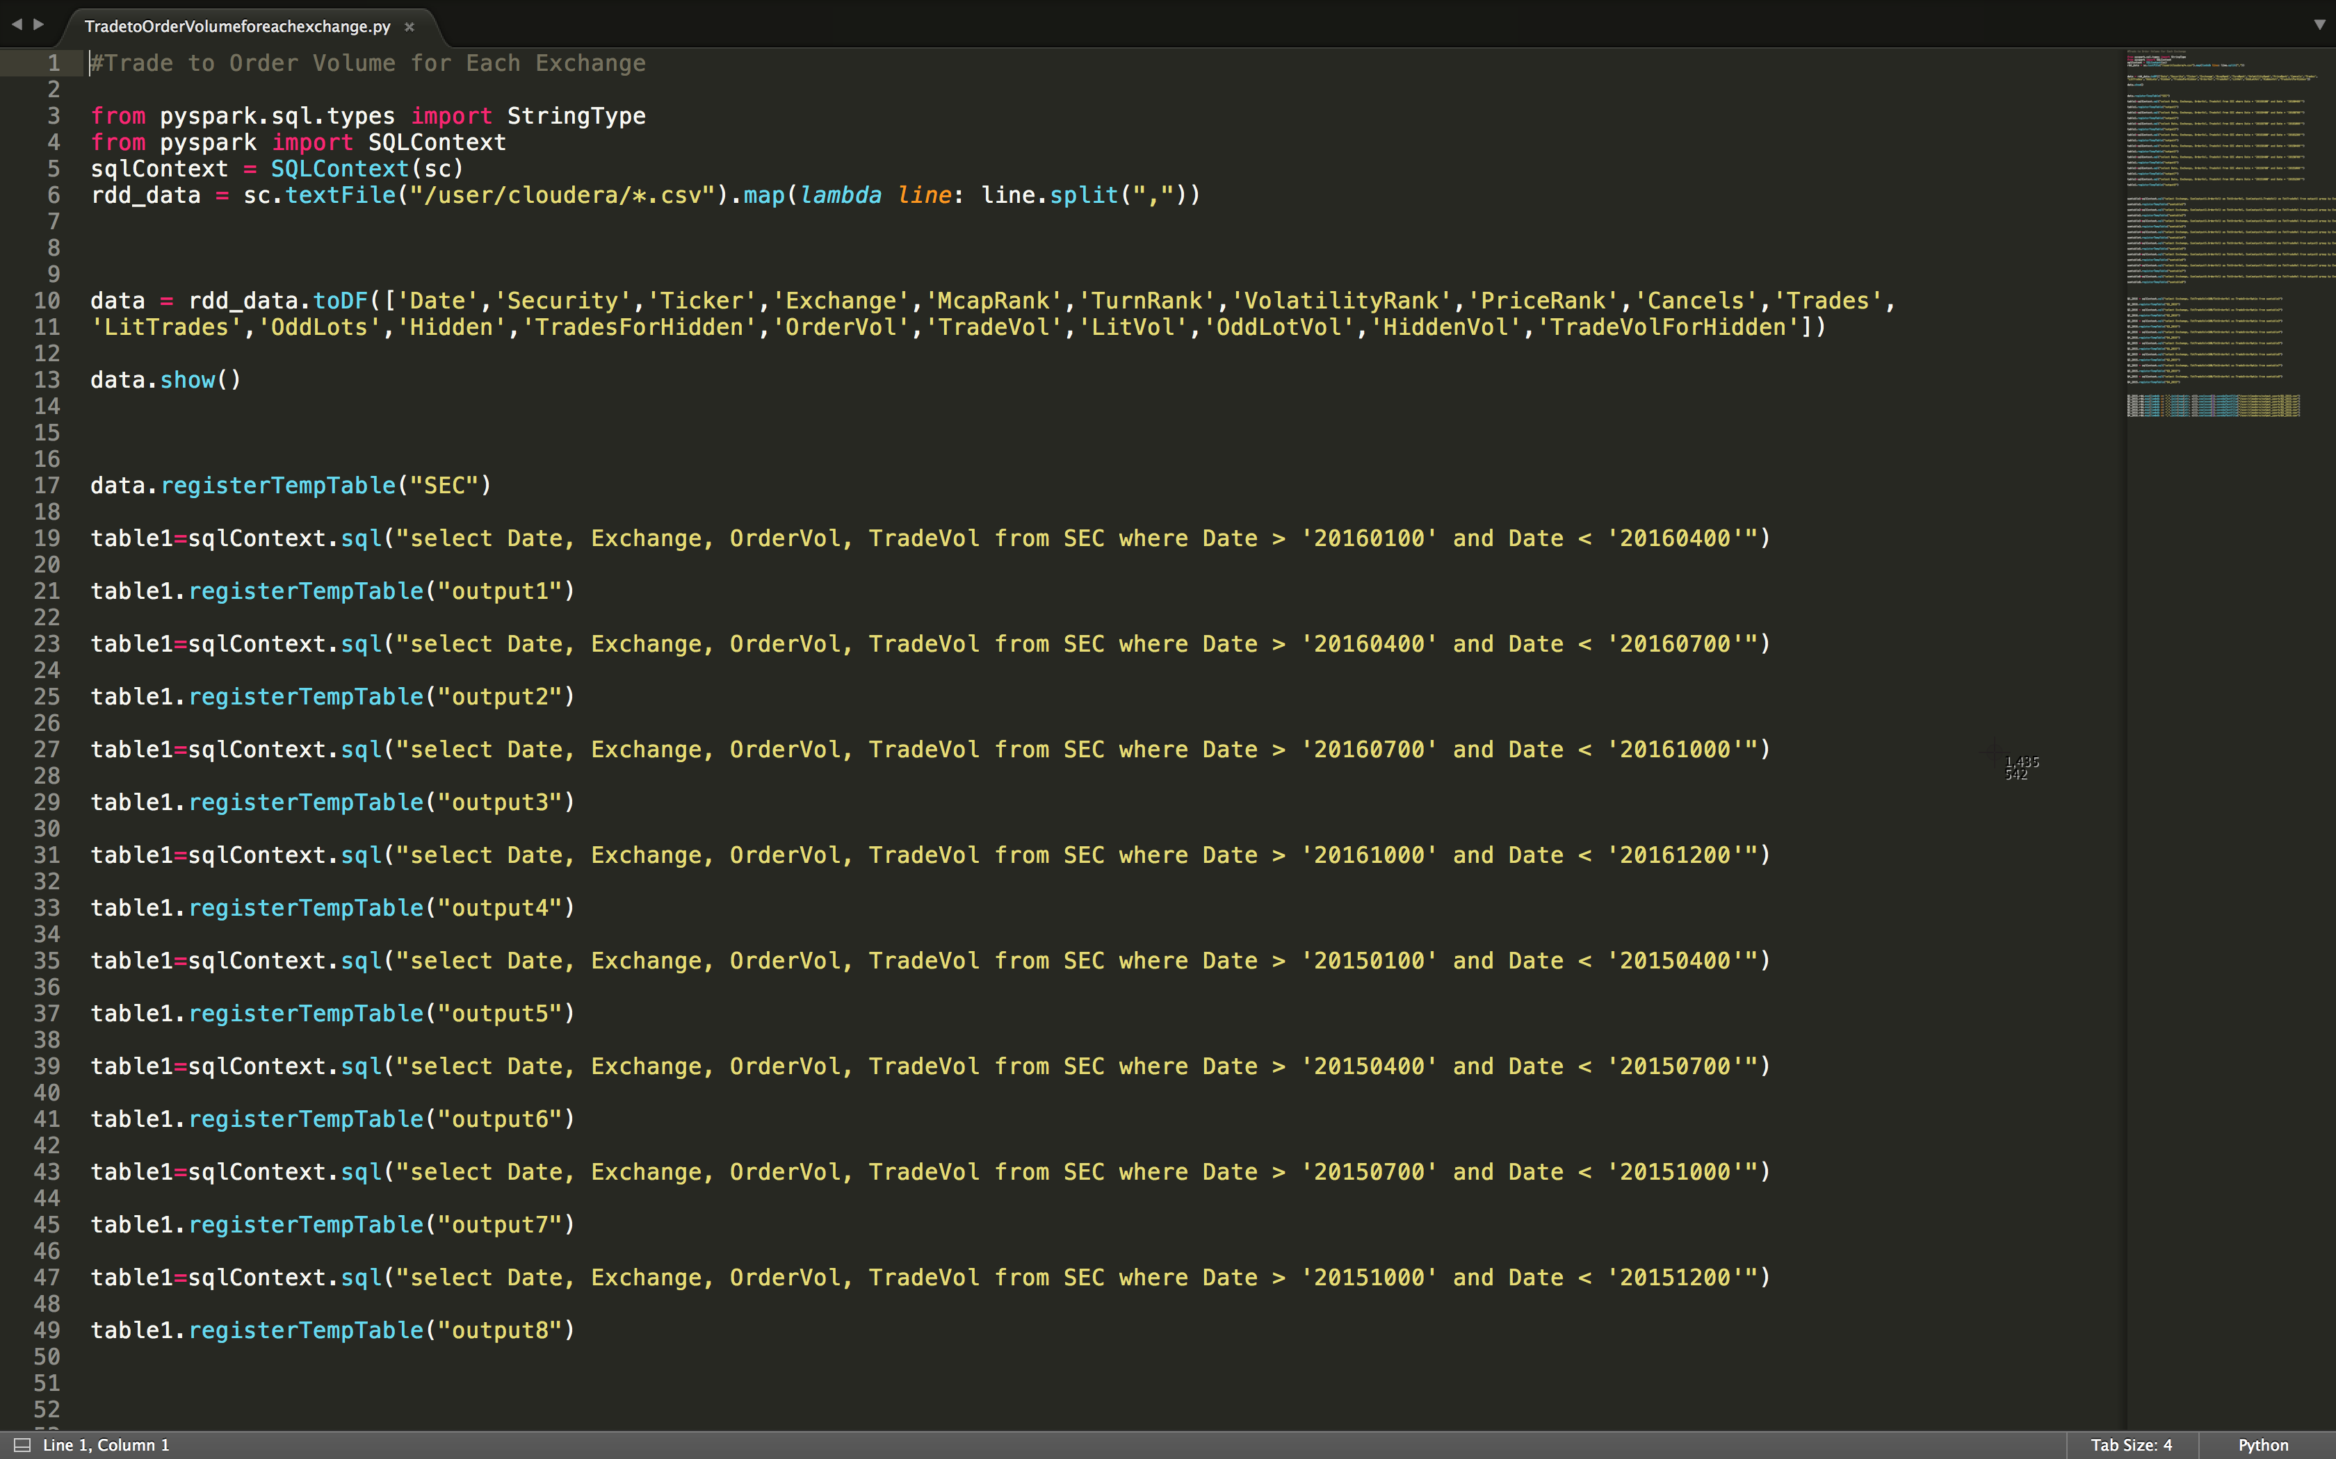

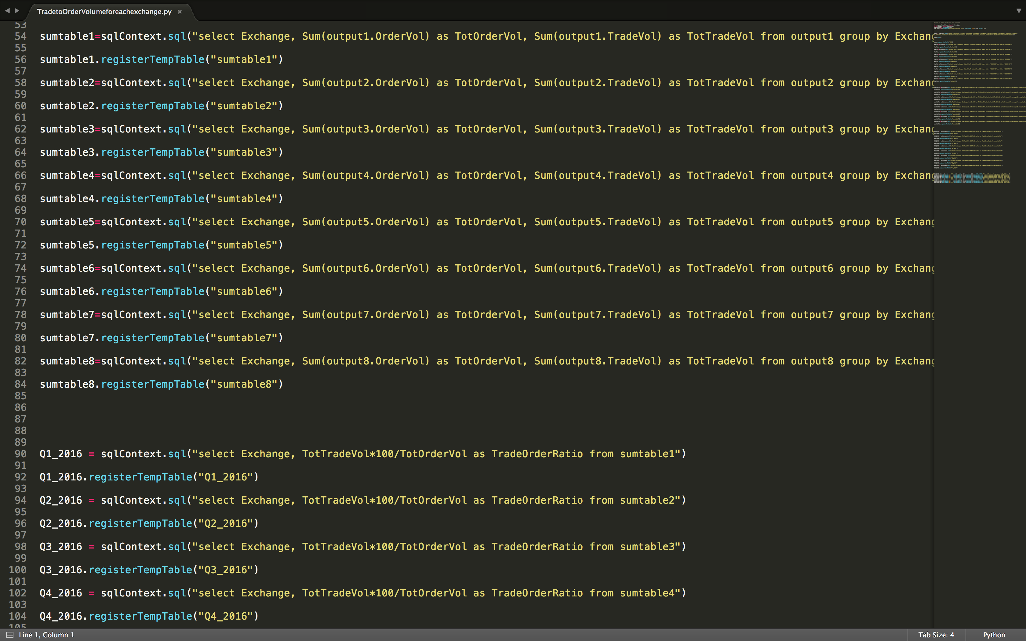

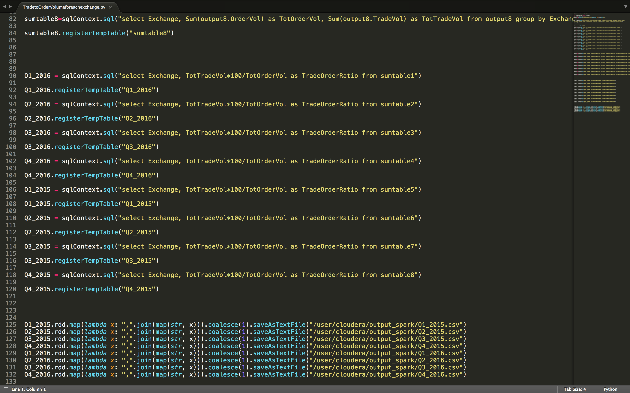

Output result for the above Spark code:

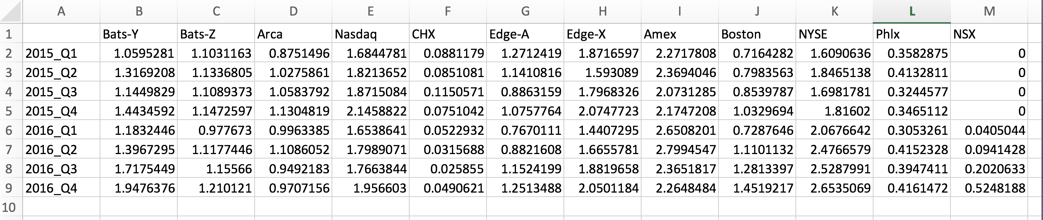

Output is plotted in Tableau:

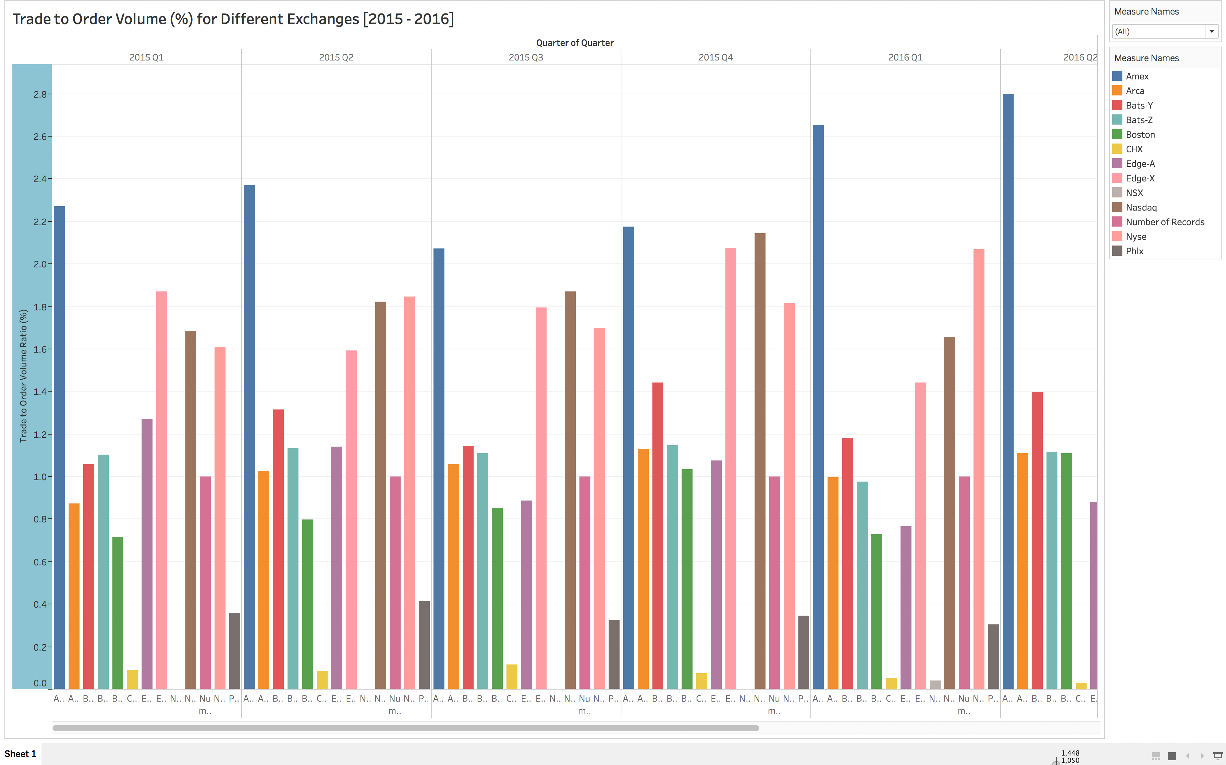

From the above Trade to Order Volume Ratio (TOR) visualization, we can infer that TOR for Amex has the maximum ratio, followed by NYSE and NASDAQ.

**Google Trend Analysis for all Exchanges:**

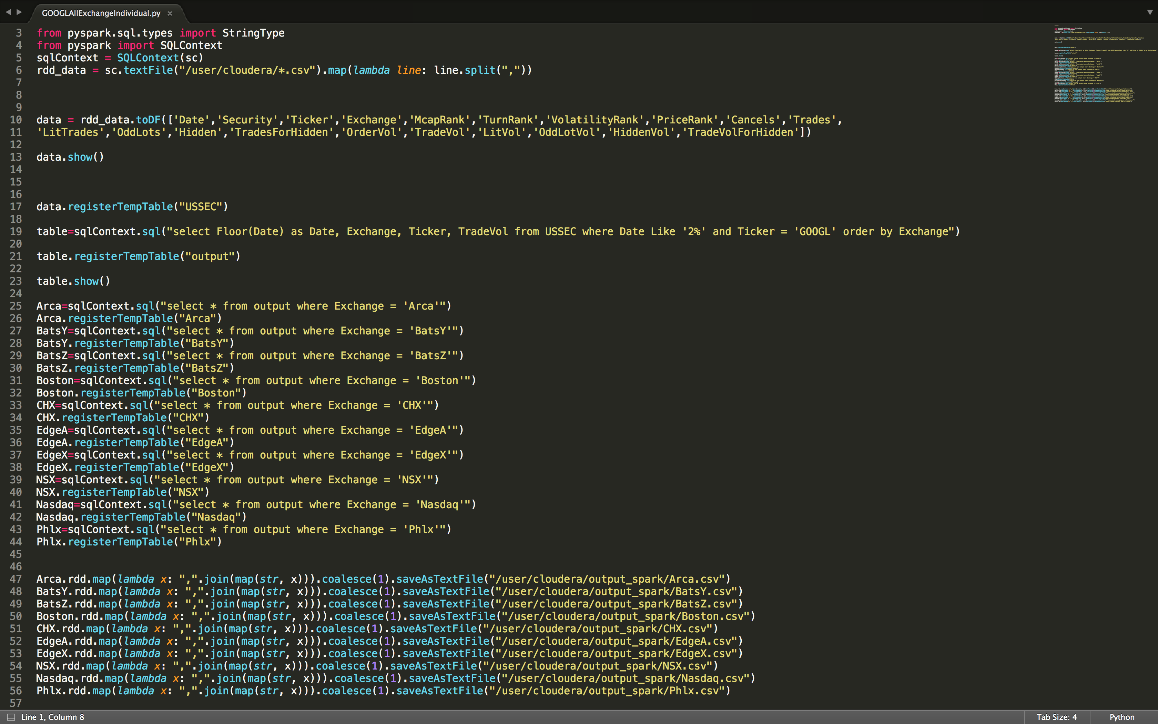

We have used R program to join the tables that have been outputted from the spark using HDFS.

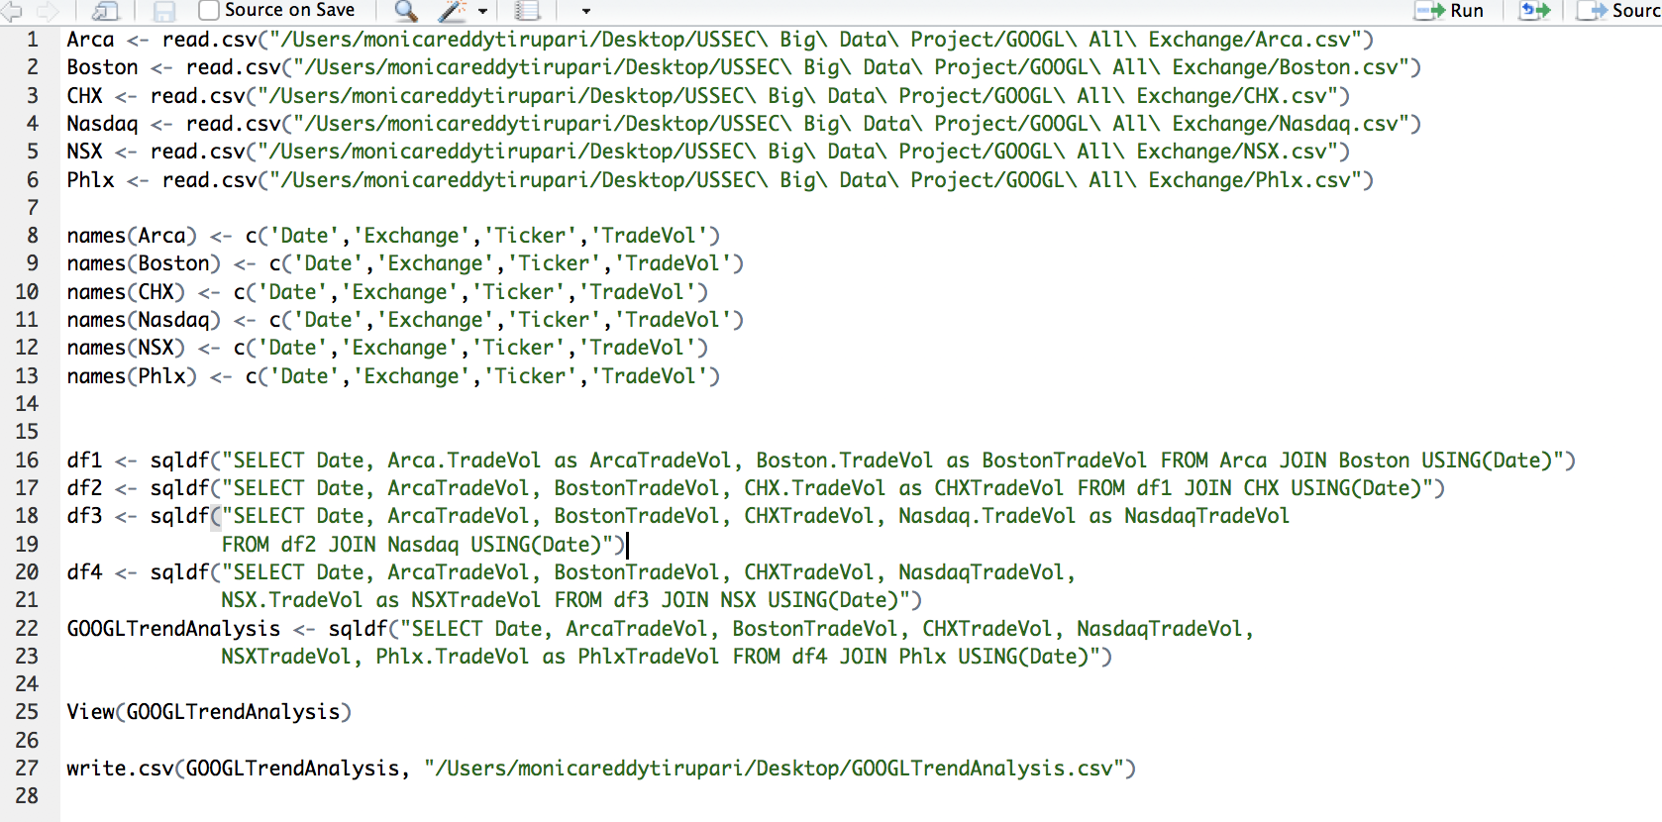

This is a Snippet of the Output data with the required attributes of Google Trade Volume for different Exchanges:

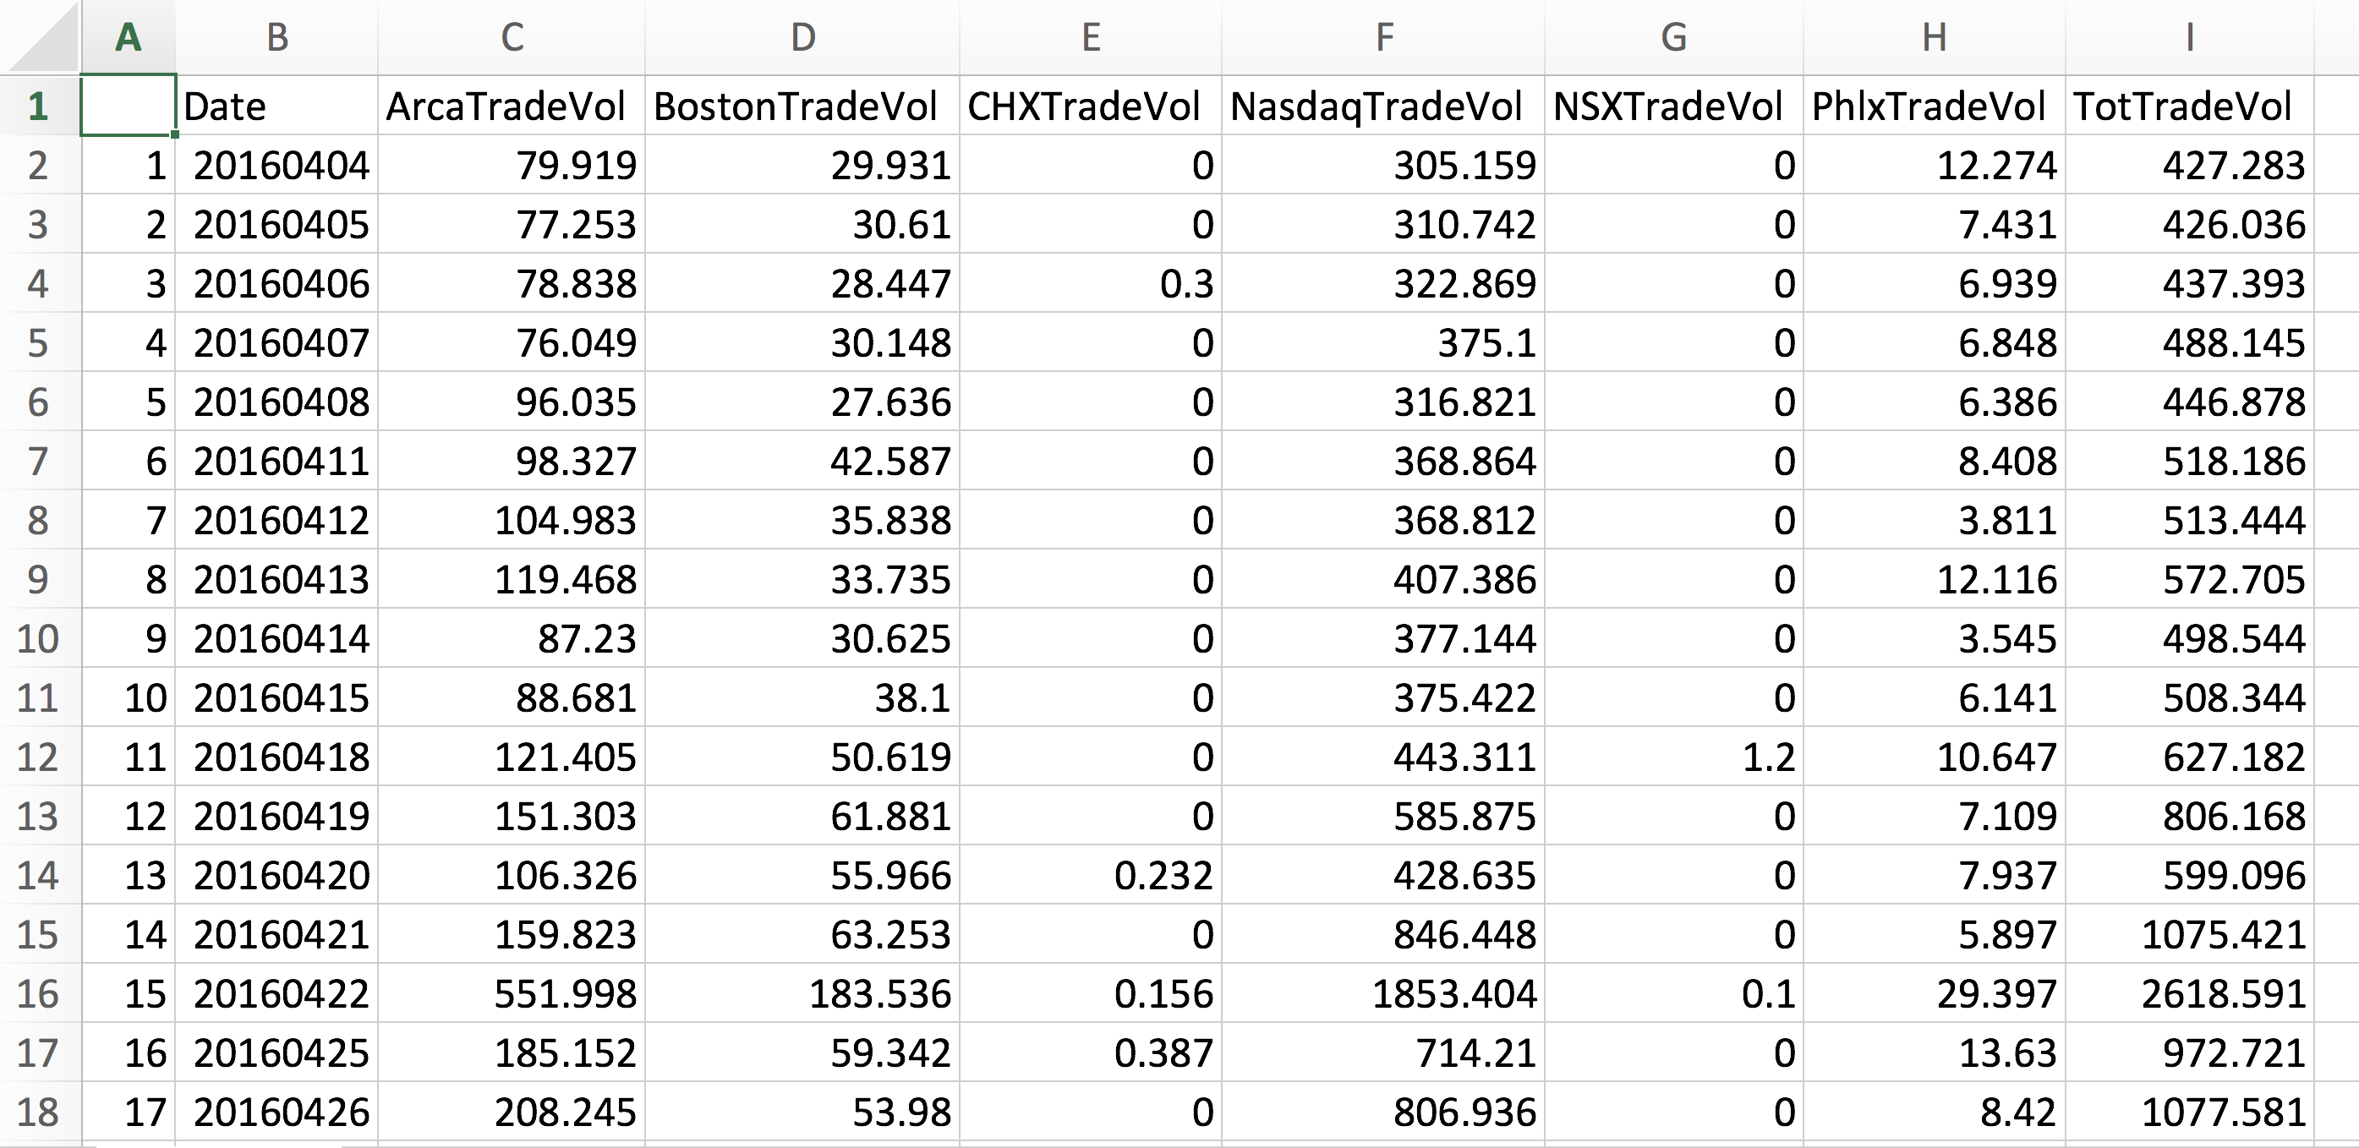

The following Trend Lines have been plotted for different exchanges using Tableau:

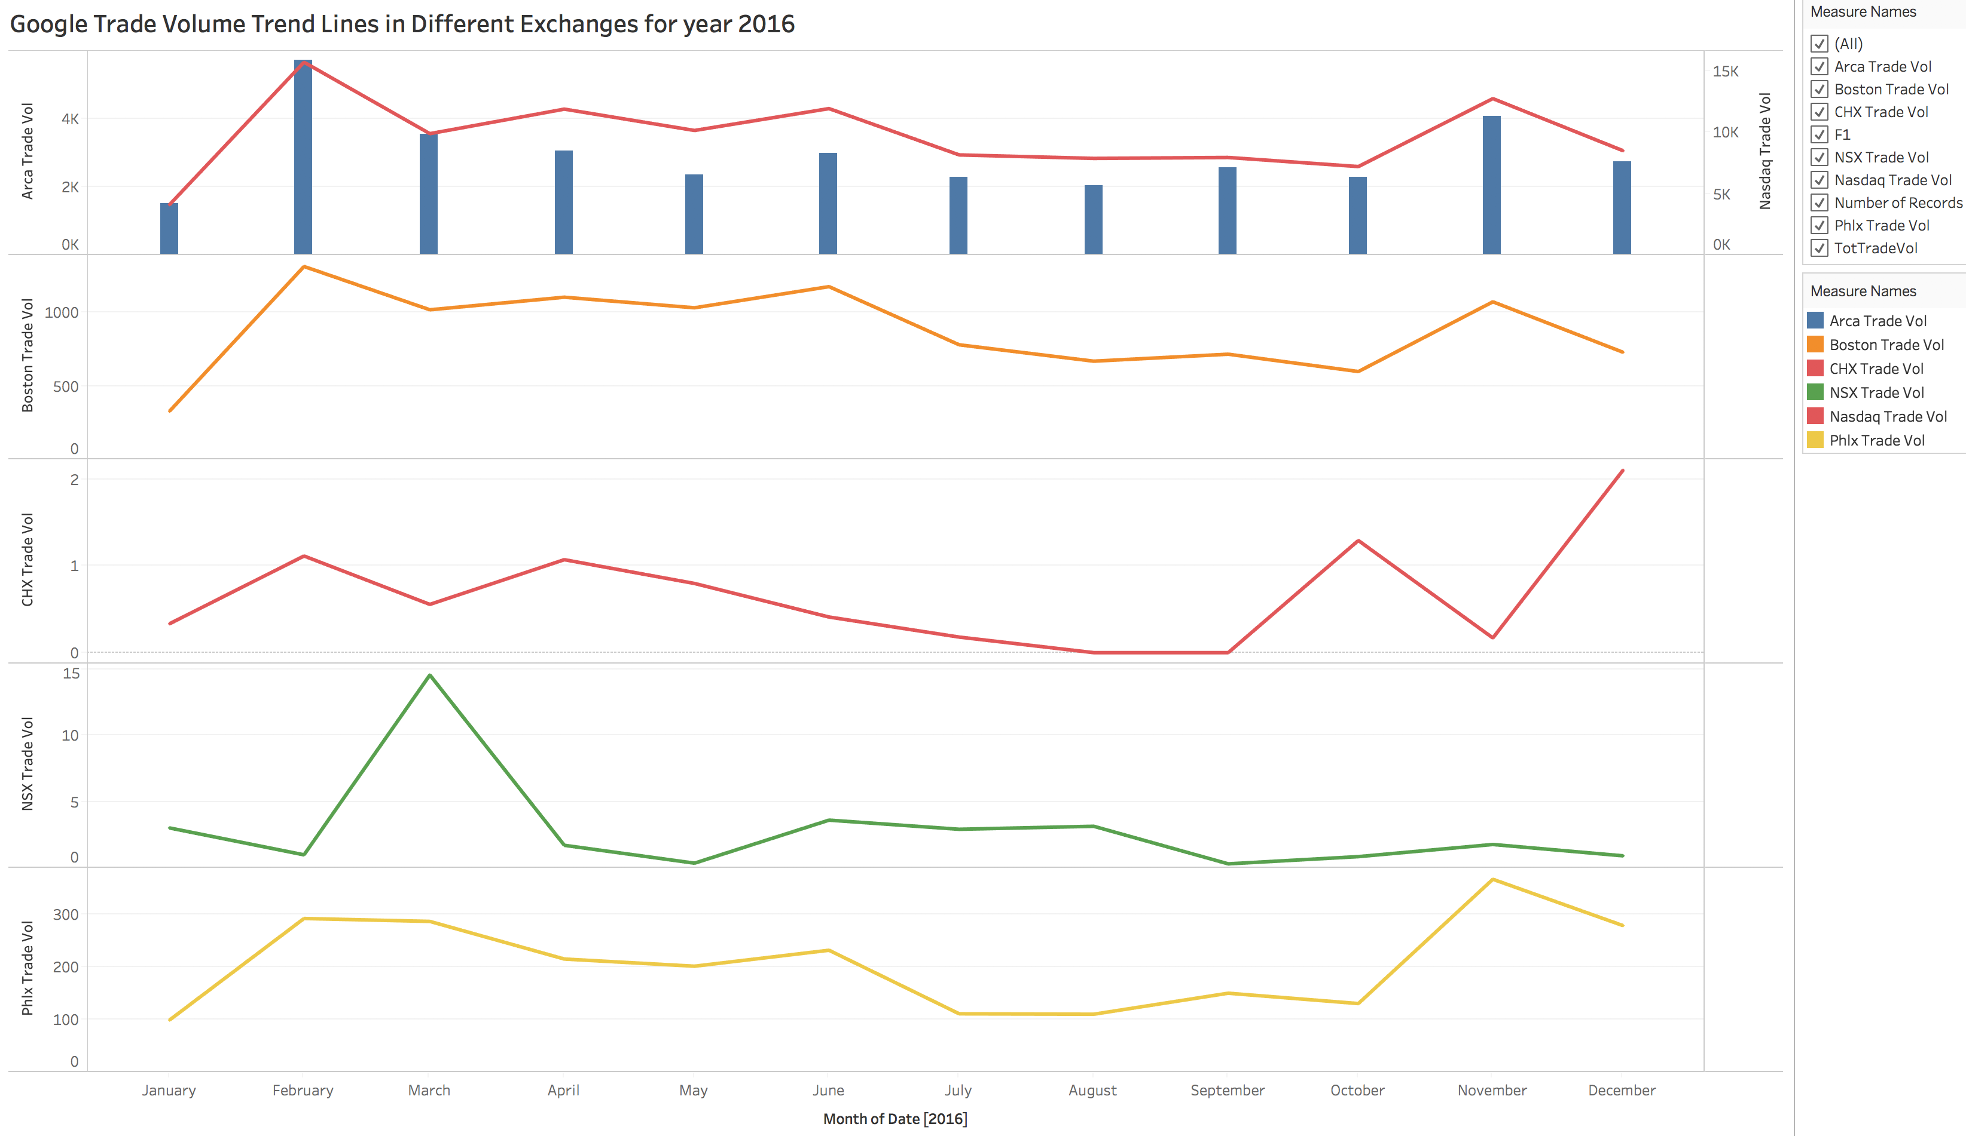

Using Python Plotly function, we have made an Interactive plot for Google Trade Volume for Nasdaq Exchange:

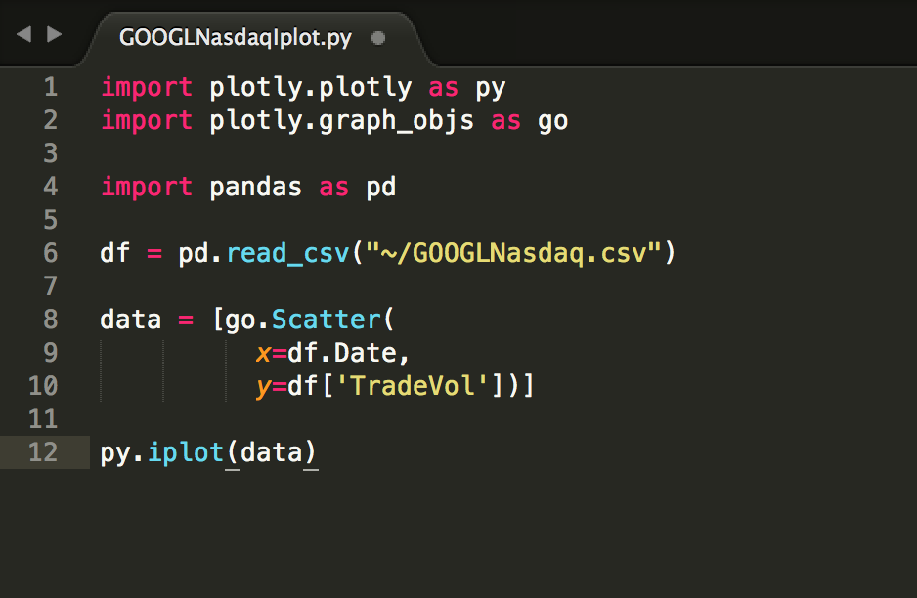

The interactive plot can be visualized using the following URL:

<https://plot.ly/~MonicaReddyTirupari/24/>

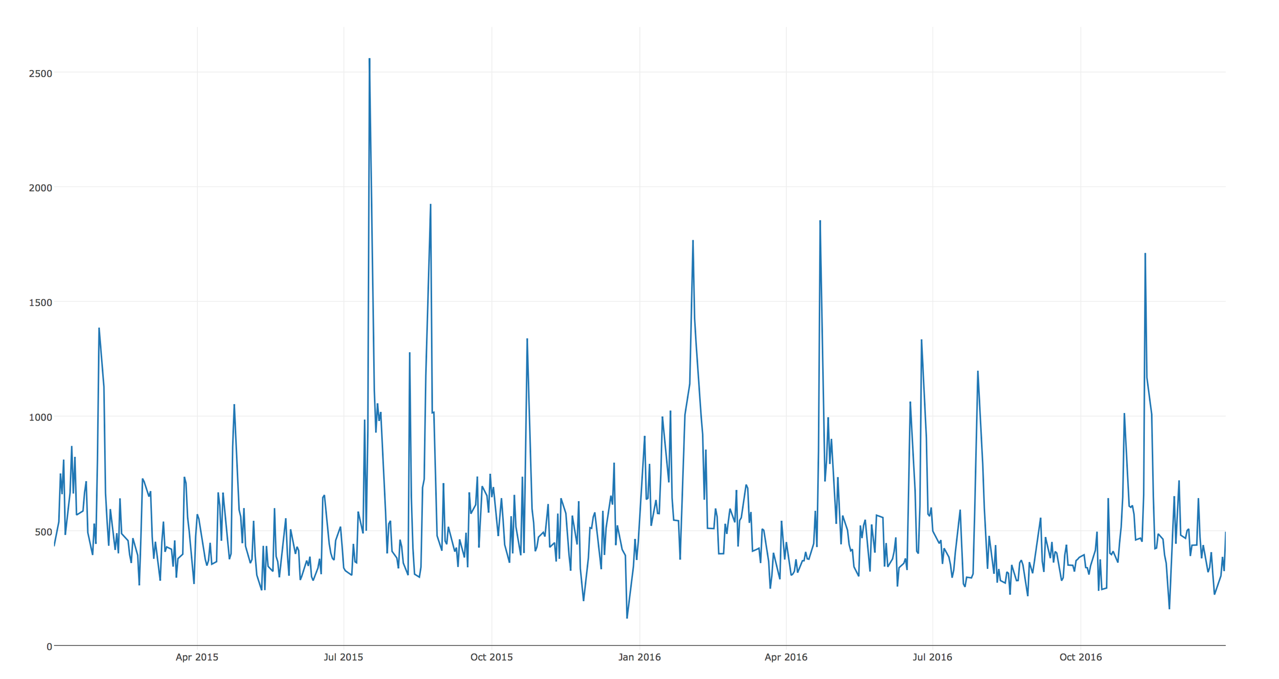

**Prediction of Google Trade Volume for January 2017:**

We have Used R Programming for the prediction using ARIMA model. We took two years of Google Trade Volume data of Nasdaq Exchange from 2015 – 2016 for the prediction and building the model.

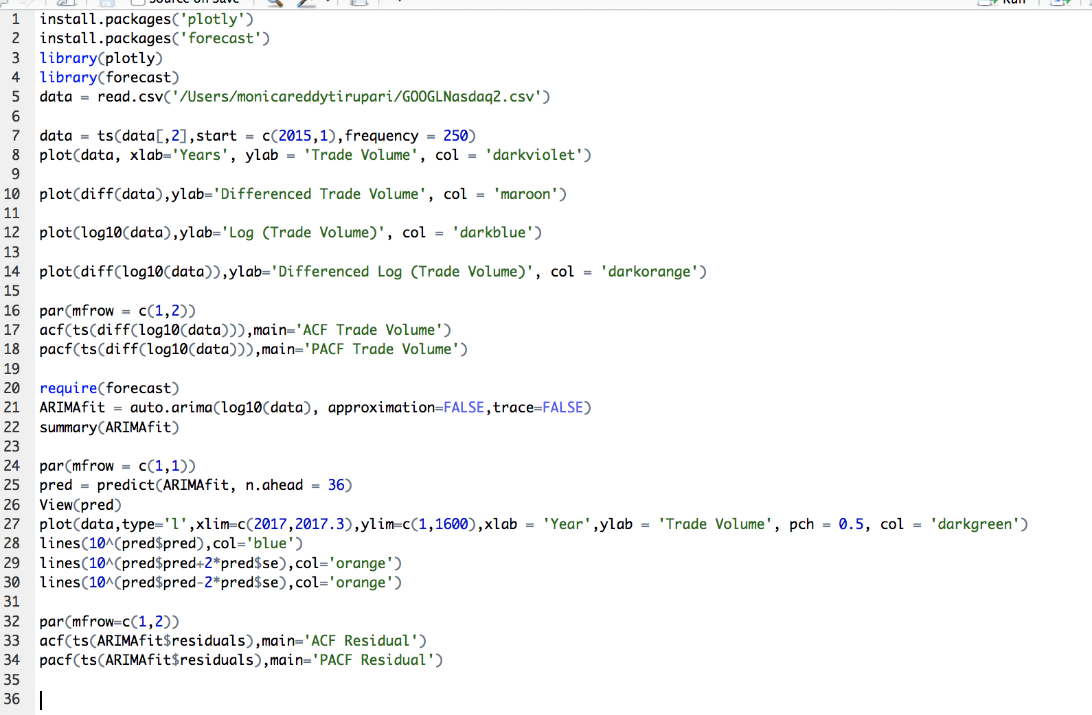

The differentiated plot obtained is a stationary time series which is essential for prediction.

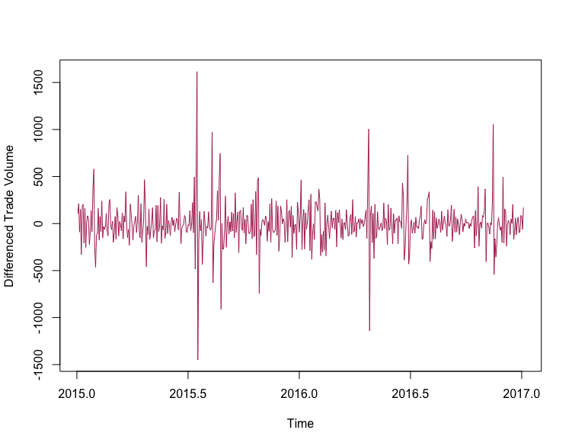

**ACF and PACF Charts for Trade Volume:**

Auto-correlated function and Partial Auto-correlated function shows how much the data is correlated and fitting the ARIMA model by training the data repeatedly. This gives us the residual charts which are perfectly correlated and gives an accurate prediction output.

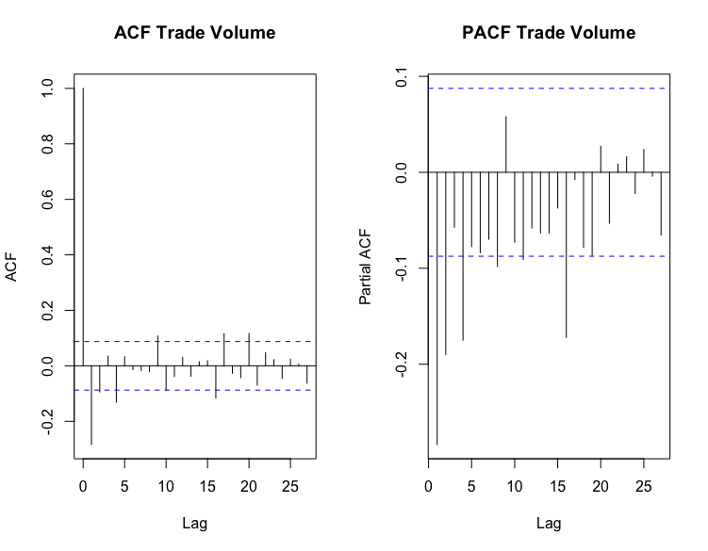 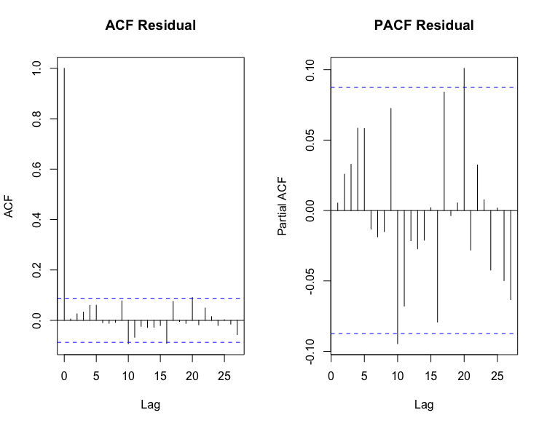

The following graph shows the prediction of Trade Volume for the month of January 2015, where it can be observed that the average trade volume is close to 470,000 Trade Volume

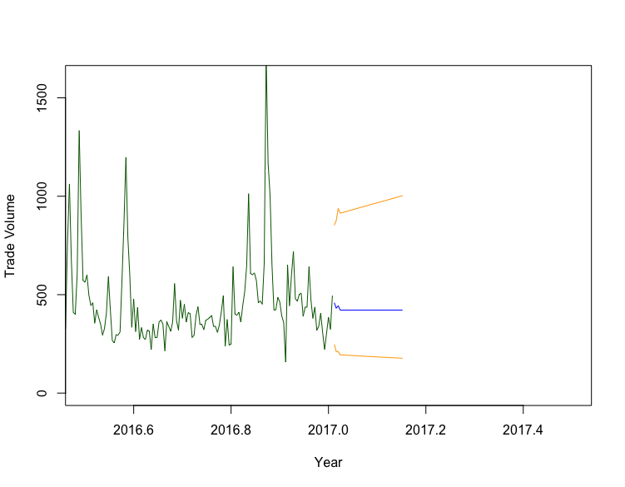

*The above graph is plotted w.r.t Trade Volume is in an order of thousands.

**Evaluating the Predicted Output:**

With the Actual data, recently available in the USSEC website. We have plotted Trade Volume of Google for January 2017 and it can be observed that the average trade volume for Nasdaq:GOOGL is 464,000 which is very close to our predicted value.

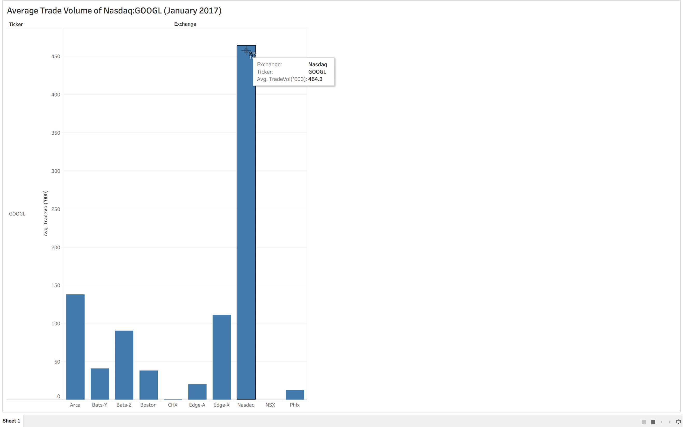

***Innovation:***

* In Stock Market, the different stock exchanges analyze and predict stock price and market capitalization but here we have analyzed various attributes of a stock and have predicted the future *trade volume* of a stock, which is not generally predicted in the stock market
* We have chosen Nasdaq Exchange for prediction because we want to hunt for high-volume stocks and it has stricter requirements than any other exchange.
* Although Calculating volume is easy. Understanding and analyzing what volume means is more important.

***Applicability***:

* Calculating volume is simply the total amount of shares traded for the day, which includes both buy and sell orders.
* While volume is only one tool of many, it adds value to your investing decision.
* If the stock that’s appreciating on high volume, it's more likely to be a sustainable move.
* If you see a stock that’s appreciating on low volume, it could be a dead cat bounce.
* Logically, when more money is moving a stock price, it means there is more demand for that stock.
* If a small amount of money is moving the stock price, the odds of that move being sustainable are lower.
* Low-volume stocks are also called illiquid stocks, buying of it could end up trapped in a pump and dump scheme.
* We have done our prediction using monthly trading volume instead of daily, to have a better idea of which stock offers more liquidity

**Reference Link:** <http://www.investopedia.com/>

Code and output files can also be found at: <https://github.com/salonibindra2050/Big-Data-Analytics>